Company Merger

Infrastructure Integration Project

Deliverable 3: Process Modeling

IS 436

Muhammad Hamza - Project Manager

[ham15@umbc.edu](mailto:ham15@umbc.edu)

443-889-8146

Siril Pattammady - Systems Developer

[psiril1@umbc.edu](mailto:psiril1@umbc.edu)

301-323-3245

Josh Johnson - Systems Analyst

[jjohn3@umbc.edu](mailto:jjohn3@umbc.edu)

240-786-8420

Khadija Shafiq - Business Analyst

[kshafiq1@umbc.edu](mailto:kshafiq1@umbc.edu)

410-508-5849

Jay Patel - Network Engineer

[jpa2@umbc.edu](mailto:jpa2@umbc.edu)

410-428-8465

Shaikha Al Shamsi - Requirement Analyst

[shaikha1@umbc.edu](mailto:shaikha1@umbc.edu)

443-515-9765

1) Develop process models using Visio, Lucid Charts (or any other drawing tool you are familiar with). The process models will include the context and level diagrams. After drawing your Level 0 diagram, detail each process in your level 0 diagram as much as possible. Therefore, you can go until level-n for each process at level 0, where n is the level at which all aspects of the business process are explained precisely. Please closely follow the notation given in PowerPoint. Your DFDs should be readable from top-left to bottom-right and should avoid crossing lines as much as possible. Make sure that the DFDs that you produce are decomposed in a meaningful way and use the principles of balancing. Do not violate the rules of data flow diagramming.

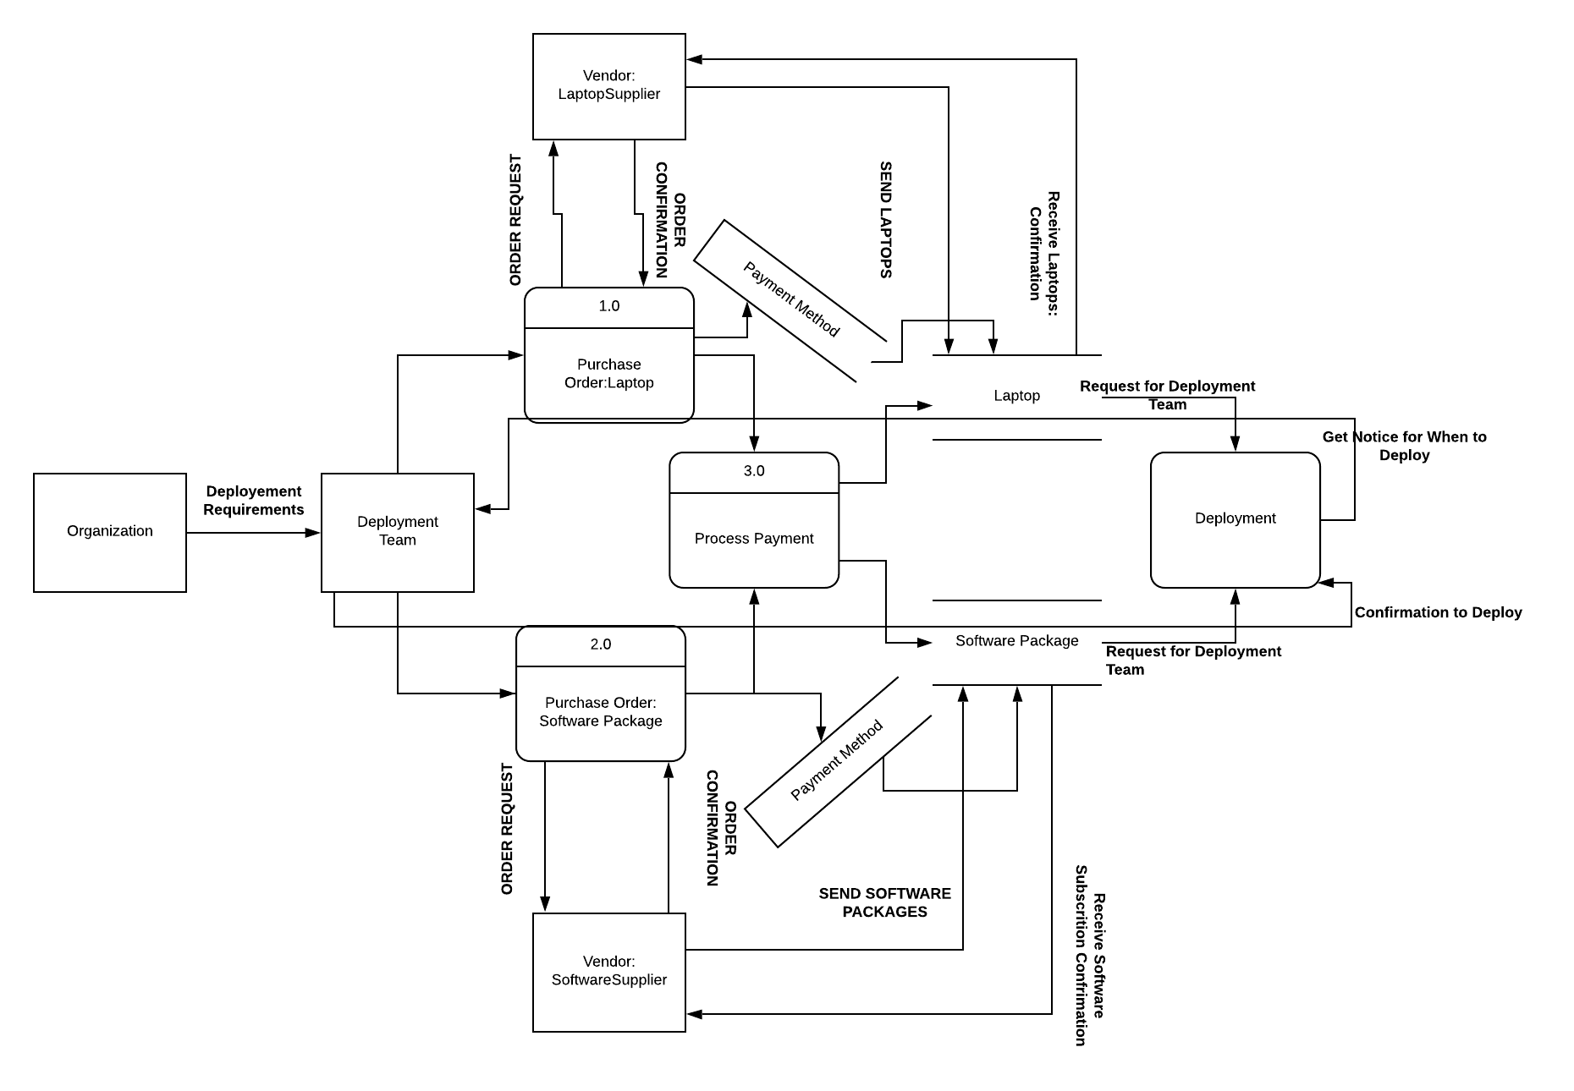

2) Revisit your Deliverable 2. Change the requirements definition and use cases that you prepared according to what you have learned by going into more detail in DFD design.

**Requirements definition document**

1. Functional and Non-Functional requirements
   1. **Functional requirements (What the system shall do)**
      1. Process-Oriented
         1. The system shall allow new laptop deployment
         2. The system shall allow new users to merge with new domain
         3. The system shall allow new IOT devices to be connected
         4. The system shall allow request from end users for changes that are needed
         5. The system shall allow different departments to be interconnected
         6. The system shall be assigned to an order to cash ERP System
         7. The system shall allow analyst and developers to make changes.
         8. The system shall be allowed to log existing data.
         9. The system shall have recovery measures for any potential outage.
   2. **Non-Functional Requirements (How the system performs a function)**
      1. Operational/Performance
         1. The system should be readily available for users and workers
         2. The system should be manageable by analysts and developers
         3. The system should be secure and recoverable for potential incident
         4. The system should be maintainable after transition from merger
         5. The system should be fairly reliable after all upgrades.
         6. The system should improve productivity and service as ‘old’ system is removed and upgraded.
         7. The system should allow users to login or create new login and password
         8. The system should allow analysts and developers to make changes
         9. The system should allow portability and universal software/OS to be uploaded throughout devices.
      2. Security
         1. The system should uphold data integrity
         2. The system should implement firewalls and protection throughout devices
         3. The system should ensure customer information is protected following HIPAA standards.
      3. Cultural and Political
         1. The system should ensure personal and customer information is protected under law and HIPAA compliant.
         2. The merger should allow both companies to work together and become one company.
         3. Should allow company standards and ethical workplace behaviour.

**Use Case# 1 Deployment Laptops Priority: High**

Actor: Deployment team

Description: Process of deploying laptops to the employees.

Trigger: When Laptops are are ready to be deployed.

Type: Internal

Preconditions:

1. Laptops are available in the facility.
2. All the accessories required with the laptop are available. Eg. Charger.

Normal Course:

1. All laptops are shipped to the facilities.
2. Check for any physical defects is performed.
3. Check for all the accessories is performed.
4. Laptops are deployed to individual departments.
5. Furthermore, laptops are sent out to the individual employees.

Alternative Course:

1. Physical defect on a laptop is found.
   1. Contact manufacturing or shipping company.
2. Accessories missing.
   1. Contact manufacturing or shipping company.

Postconditions:

1. Laptops are provided to the individual departments.
2. Laptops are provided to the individual employees.

**Use Case# 2 Conversion from QAD to SAP Priority: High**

Actor: Integration Team

Description: Process of converting from an ERP- QAD to SAP .

Trigger: Non-working hours.

Type: Internal

Preconditions:

1. Request to the QAD system is significantly less(non-working hours).
2. The QAD system’s maintenance hours have been posted to inform the employees.

Normal Course:

1. Integration team checks the number of requests on the QAD system for a certain time.
2. Sends a maintenance information to all the employees who uses QAD system.
3. Performs the conversion process from QAD to SAP.

Alternative Course:

1. Number of requests on the QAD system is high.
2. Schedule another time for maintenance.

2. Maintenance information was not to all the employees who uses QAD system.

1. Potential risk of someone working on the system and QAD goes down.

Postconditions:

1. QAD system is converted to the SAP system.
2. All users can access SAP system.

**Use Case# 3 Uploading Software on Devices Priority: High**

Actor: Software deployment team

Description: Process of uploading software packages on end users devices

Trigger: When Laptops are all deployed

Type: Internal

Preconditions:

1. Laptops deployed to department
2. Software team has all software packages on hand
3. Time frame of when software has to be deployed on devices

Normal Course:

1. Obtain all laptops on hand
2. Software team to order all licensing agreements and packages for applications to be downloaded
3. Arrange time for deployment
4. Have teams login to laptops and import all software packages/licensing on devices
5. Have all laptops completed and ready for user to login

Alternative Course:

1. Laptop subscriptions not working
   1. Contact company
2. Time Management
3. Laptops not arrived
   1. Contact deployment team for expected date
4. Laptop issues
   1. Contact the IT help desk to configure laptops
5. Laptops not ready to be delivered to end users
   1. Inform users of delay

Postconditions:

1. Software packages on all devices
2. User login and passwords created for all work users
3. Laptops and devices finished deployment

3) Provide a simple text definition for each process, entity, datastore and each data flow in your diagram. Pay attention to the data flow names – each should be unique if they are carrying unique data.

High Level :

**Laptop Deployment**

With regards to laptop deployment, the initial step would be procurement. Upon the successful acquisition of the specified laptop devices, the next step would be to allocate the laptops to target individuals in order to load necessary programs and applications. The exact programs that would need to be necessary for each department may vary, although this process can occur on an ongoing basis. To complete this process, the laptops will be ‘tagged’ and assigned to target individuals and integrated into the company’s systems.

**Conversion from QAD to SAP**

The biggest segment to this project would be the conversion process from the QAD ERP software to the SAP software. This would include creating backups for all data sets in order to ensure redundancy and to verify the integrity of all current data. With regards to financial security, it’s imperative to ensure that the newly transitioned data sets are accurate and verified. Any anomalies will require special attention in order to acknowledge any faults or errors that were encountered. In the case of a successful conversion, a simple doublecheck would allow us to acknowledge the completion of the process.

**Software Implementation**

The software implementation should be fairly simple to accomplish. This would include determining which particular software should be implemented on the said laptops in order to allow off-prem work to be completed remotely. A VPN would be required in order to provide a secure tunnel between the staff members’ home networks straight to the company’s internal network. After all software implementations have been made, the laptops can be assigned to staff members and physically distributed.

**Definitions for DFD Laptop Deployment:**

**Organization**: Merger between Osiris and Smith & Nephew Company. Defined to show the high level commands/requirements that are needed for the merger for deployment.

**Deployment Team:** Follows rules from the organization based on requirements and what is needed for a successful deployment. Focused on deploying laptops with software packages.

**Vendors:** Vendors that provide the resources for organizations successful deployment such as laptops and software packages.

**Process - Purchase Order: Laptop** :Request to purchase laptops for organization through vendor.

**Process- Purchase Order:Software Package**: Request to purchase software subscription and packages through vendor

**Process Payment:** Handles transaction between vendor and organizations deployment team by taking form of payment and order confirmation based on request. Vendor sends item and waits for delivery confirmation

**Process Deployment**: Waits till all process are done, sends a request to deployment team for them to decide if deployment is ready. When ready deployment is underway.

**DataStore:** Laptop, Software Package, Payment method all stored and recorded for deployment team to decide if deployment is ready.

4) Include your updated project plan.

|  |  |  |  |  |  |
| --- | --- | --- | --- | --- | --- |
| TASK ID | TASK NAME | Estimated | | | |
| Assigned to: | Duration | Start date | Finish date |
| 1 | **Planning** | Hamza, Shaikha, Siril, Khadija, Josh, Jay | 4 weeks | 9/25/2019 | 10/23/2019 |
| 1.a | Gathering Requirements | Shaikha, Khadija | TBD | 9/26/2019 | 9/30/2019 |
| 1.b | Create a project plan | Siril, Jay | TBD | 9/31/2019 | 10/15/2019 |
| 1.c | Financial planning | Hamza, Josh | TBD | 10/16/2019 | 10/23/2019 |
|  |  |  |  |  |  |
| 2 | **Analysis** | Josh, Khadija, Hamza, Shaikha | 3 weeks | 10/23/2019 | 11/13/2019 |
| 2.a | Understanding Requirements | Hamza | TBD | 10/23/2019 | 10/31/2019 |
| 2.b | Examining changes required | Josh | TBD | 10/31/2019 | 11/05/2019 |
| 2.c | Business Analysis | Khadija | TBD | 11/06/2019 | 11/10/2019 |
| 2.d | Systems Analysis | Josh | TBD | 11/10/2019 | 11/13/2019 |
|  |  |  |  |  |  |
| 3 | **Design** | Jay, Siril, Hamza | 3 weeks | 11/13/2019 | 12/4/2019 |
| 3.a | Possible Design Options | Jay, Siril, Hamza | TBD |  |  |
| 3.b | System Design | Siril | TBD |  |  |
| 3.c | Network Infrastructure | Jay | TBD |  |  |

5) Create a Kanban board and assign the requirements to your team members.

